SOP of Backing up the PecStar iPQMS V3.5 Database

Back up the PecStar iPQMS V3.5 Database in SQL Server
Please follow these steps to back up the PecStar iPQMS V3.5 Database in SQL Server.
- Open SQL Server Management Studio from the Windows start menu.
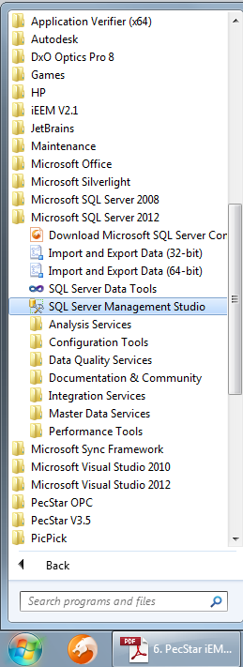

- Connect to the appropriate instance of Microsoft SQL Server Database Engine.
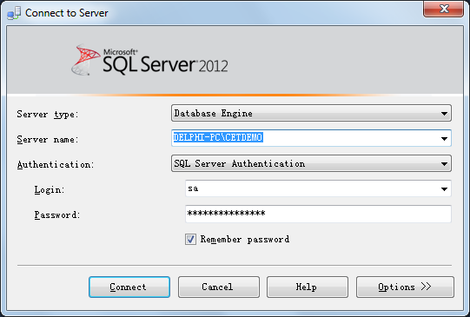

- In Object Explorer, expand Databases node.
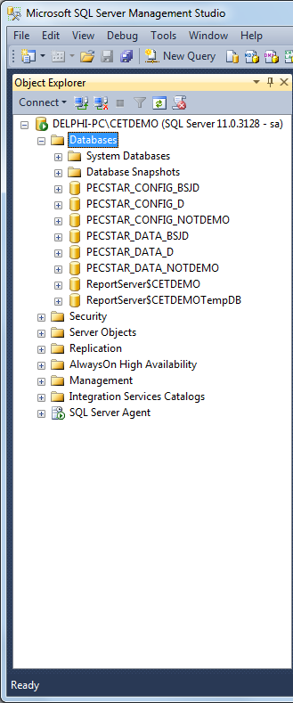
Note: The PecStar iPQMS contains two databases: the CONFIG database and the DATA database. Their names are:
PECSTAR_CONFIG_PROJECT NAME
PECSTAR_DATA_PROJECT NAME
First, back up the PECSTAR_CONFIG_PROJECT NAME database following the procedures:
- Right-click the database which you want to take a full backup and select Tasks-> Back Up…
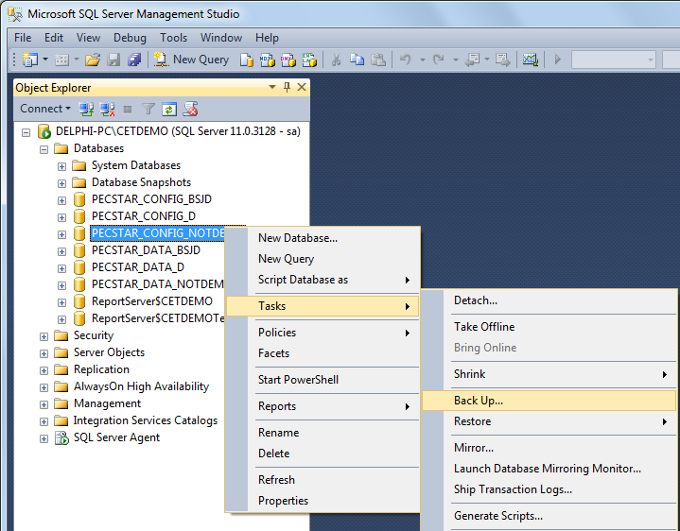

- The Back Up Database dialog box is open, as shown below. In Backup type list box select Full. In Backup Component select Databases and in Backup set optionally enter Description and leave other items as default.
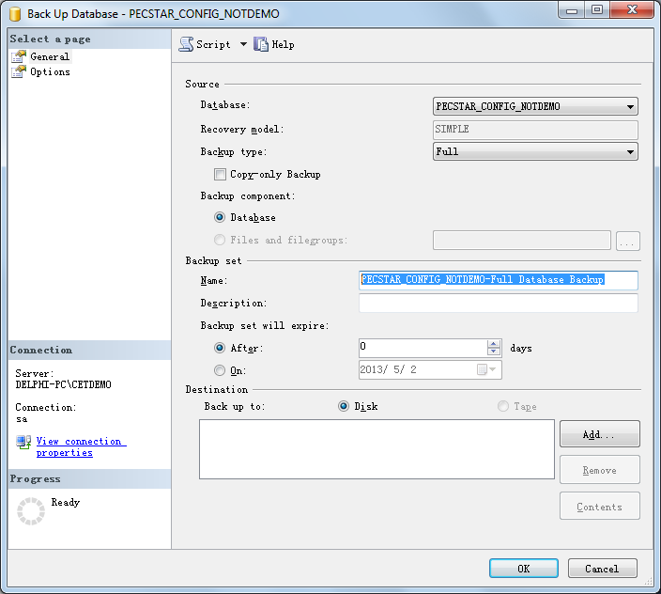

- In Destination, click Add to select the file or backup device for the backup destination as shown below.
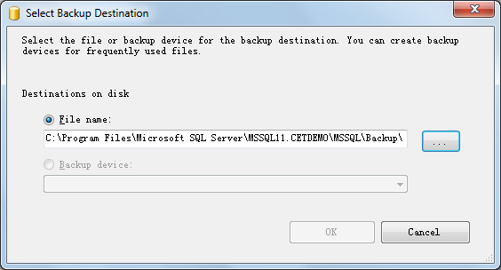

- Click the button to select the path where to save the backup file and enter File name of the backup file and click OK to return.
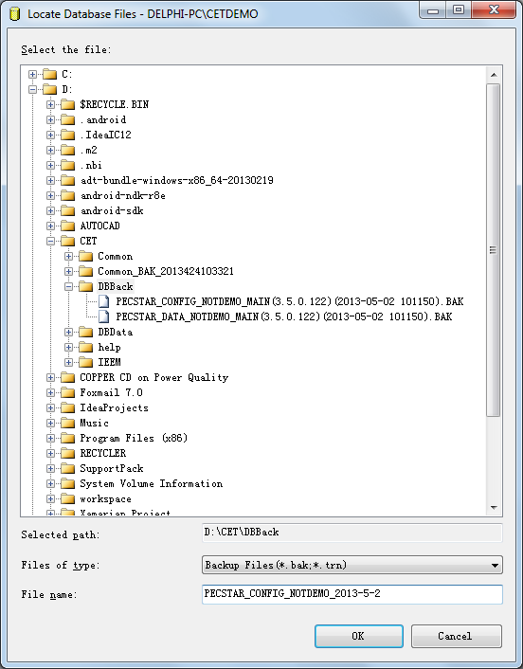

- Click OK in Select Backup Destination dialog box.
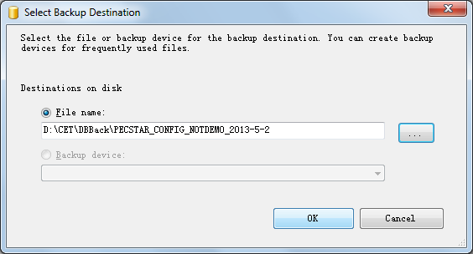

- Once you have completed the General settings you will be able to see a screen similar to below figure. Click OK in Back Up Database dialog box to perform the backup task.
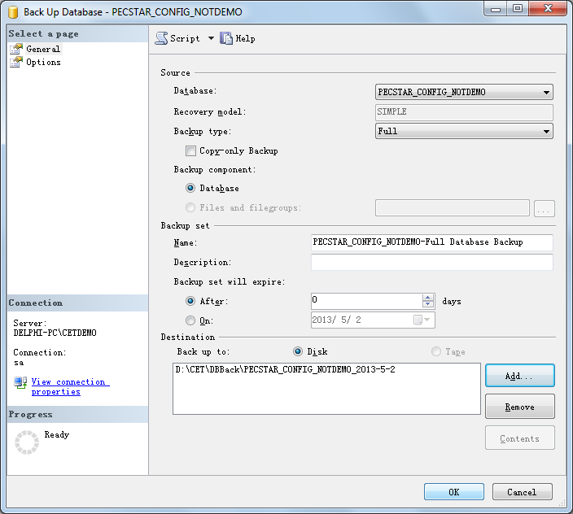

- Once the database is successfully backed up you will get a popup message similar to the one as shown below.
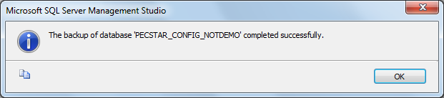

- Then follow the same procedures from 4 to 10 to back up the PECSTAR_DATA_PROJECT NAME database.
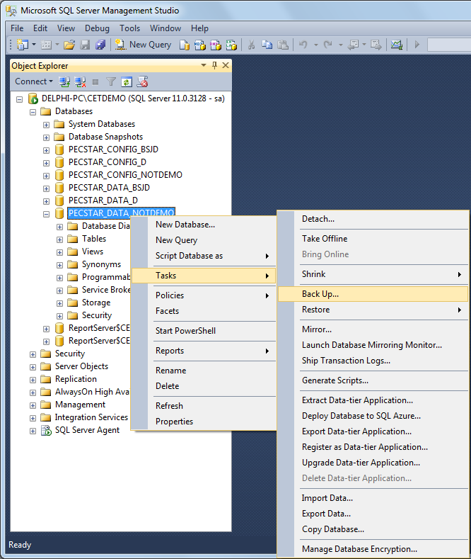
- Navigate to the backup destination to check the two backup files(the .bak files). Compress the two files into one .rar or .zip file if needed.

